Exploration and Requirements

Table of Contents

Project Overview 2

Target Audient 2

Technical Approach 2

ASP.NET 2

Java 3

Azure 3

HTML5/CSS 3

JavaScript/JQueryMobile 3

XML 3

CSV 3

Entity Framework 4

SQL 4

User Stories 4

Log In 4

Create Tables 5

Table Exports 5

Admin Access 6

Account Creation 6

Public URLS 7

Mobile Forms 7

Release Plan 8

Bibliography 9

# 

# Project Overview

The project attempts to simplify the sign up and registration process by allowing for an electronic solution to the traditional pen and paper approach still widely used today. Large-scale form processing applications may be impractical for smaller businesses or personal uses. Creating the data in a digital format from the offset eliminates unnecessary data input and simplifies the process for the user. Capturing this data digitally allows demographics and other statistics to be generated quickly and conveniently.

Application integration is an important aspect of this system, as users will invariably wish to process this data with any number of applications for use in mailing lists, etc. .CSV files are supported by a wide variety of applications and as such we feel this is the best format to focus on for export purposes.

The Application encompasses a Web Service built on the ASP.NET platform and Database backend implemented using Entity Framework and SQL Database on Microsoft’s Azure platform and a Client side application and Web App.

# Target Audient

The application can serve a wide range of purposes but is primarily aimed at small to medium businesses, Charity organisations and personal use.

The application would be suitable for use at events such as trade fairs employment fairs, conventions, seminars, and charity functions. Tablets running the application could be installed in stores for customers, allowing businesses to engage customer footfall with the e-commerce side of the business as well. Door-to-door salespersons, street teams or personal users organizing trips, meetings or college society sign ups may also find the application useful.

# Technical Approach

## ASP.NET

The ASP.NET MVC platform has been chosen to provide the HTML view of the full browser web page, user authentication and to provide backend integration with the server and database. This language is one of our required Microsoft technologies as part of our entry into Microsoft’s Imagine Cup competition.

Some of the benefits of ASP.NET over other possible solutions such as PHP include a higher level of abstraction, allowing easier development in a short time period. (MICROSOFT) Operating in a more familiar OOP development environment will lead to increased productivity and a smaller learning curve. ASP.NET can also be fully integrated with Microsoft’s Azure service, whereas with other programming languages the Azure SDK does not include a full set of Azure APIs at present leading to more complex code when it comes to integrating. (PARKER, 2011)

## Java

The app is to be developed using the Java programming language with the Android SDK as a native android app for use with both tablets and smartphones. (ANDROID) Android development is supported cross platform between Mac OS X, Windows and Linux Operating systems through the Eclipse IDE which accommodates both members of the programming teams home operating systems. (ANDROID)

## Azure

Windows Azure is a cloud computing solution developed by Microsoft. This platform provides us with many benefits including the following:

Websites can be deployed using ASP.NET using Git or FTP, SQL Database, an API built on REST, HTML and XML, Azure integrates well with Git and Eclipse. (MICROSOFT)

## HTML5/CSS

HTML 5 technologies will be used in both the full browser implementation of the site and in combination with other technologies to develop the front end of the mobile application. HTML5 was developed to provide flexibility and allow more to be accomplished with stand alone HTML. Some of the major benefits associated with HTML is the addition of the canvas and video tag as well as support for geolocation, client side local storage/database, offline cache and support for basic threading. (W3SCHOOLS)

## JavaScript/JQueryMobile

jQuery Mobile integrates HTML5, CSS3, jQuery and jQuery UI into a touch-optimized, cross platform mobile framework. It is designed to enhance development and to support a wide range of mobile platforms. Ajax support will prove invaluable to the project. For these reasons we have decided to use jQuery Mobile in combination with an Android SDK for developing a hybrid version of the application. (JQUERY)

## XML

XML and JSON will be the main data formats used for communication between mobile device’s and the server. Due to limitations of mobile devices, a vast amount of apps have to transmit large amount of data over the Internet in order to deliver full functionality to the user. XML and JSON are the most common data exchange formats today and they both offer flexible and capable approaches to this problem. (IBM)

## CSV

The so-called CSV (Comma Separated Values) format is the most common import and export format for spreadsheets and databases. Surprisingly, while this format is very common, it has never been formally documented. so the format is operationally defined by the many applications which read and write it. (PYTHON.ORG)

## Entity Framework

Entity Framework (EF) is an object-relational mapper that enables .NET developers to work with relational data using domain-specific objects. It provides a layer of abstraction that allows us to bypass the use of SQL statements to access and modify relational databases.

## SQL

To dynamically create user tables we will use a combination of Entity Framework and SQL. Template tables will be created using Entity Framework to allow users to specify customer columns which will then be committed and stored as an SQL table in the database.

# User Stories

### Log In

|  |  |  |  |
| --- | --- | --- | --- |
| **ID: 1** | **Story Title: Log In** | **Priority: High** | **Estimate: 2 hours** |
| As a user I want to log in so that I can access my account | | | |

**Confirmation:**

1. **Success** – valid user logged in and referred to personal home page
   1. User Presented with a list of their associated sheets table entries.

Which can be selected to view the individual signatories.

1. **Failure** – display message
   1. Username and hash of password does not match that stored in the database.
   2. Display failed login message, allow retry up to 3 attempts.

### Generate Registration Form

|  |  |  |  |
| --- | --- | --- | --- |
| **ID: 2** | **Story Title: Generate Registration Form** | **Priority: High** | **Estimate: 5 hours** |
| As a User I want to generate custom registration forms so that I can capture data from clients | | | |

**Confirmation:**

1. **Success** – Valid table names provided, table created, stored and associated with user profile
   1. User returned to list of tables including newly created one.
2. **Failure** – Invalid Input
   1. User enters values disallowed by form validation
      1. Indicated by highlighting invalid field
   2. Failed table creation
      1. Notify user and allow retry

### Select Input type

|  |  |  |  |
| --- | --- | --- | --- |
| **ID: 3** | **Story Title: Select Input Type** | **Priority: High** | **Estimate: 5 hours** |
| As a User I want to select predetermined input types (radio buttons, checkboxes) for certain custom fields, and be able to specify custom answers. | | | |

**Confirmation:**

1. **Success** – Table created with defined input types and default question layout.
   1. User returned to list of tables including newly created one.
2. **Failure** – Invalid Input
   1. User enters values disallowed by form validation
      1. Indicated by highlighting invalid field
   2. Failed table creation
      1. Notify user and allow retry

### Table Exports

|  |  |  |  |
| --- | --- | --- | --- |
| **ID: 4** | **Story Title: Table Exports** | **Priority: High** | **Estimate: 5 Hours** |
| As a User I want to export Tables so that I can easily import them to other applications. | | | |

**Confirmation:**

1. **Success** – File downloaded to client machine.
   1. File downloaded to client machine at user defined location
2. **Failure** – Cannot export table.
   1. Table may be being updated by another device (AJAX call)
   2. Table not found

### Admin Access

|  |  |  |  |
| --- | --- | --- | --- |
| **ID: 5** | **Story Title: Admin access** | **Priority: High** | **Estimate:4 Hours** |
| As a sit administrator I want access users information to build profiles and send emails. | | | |

**Confirmation:**

1. **Success** – View list of usernames, full names, location and email addresses.
   1. View displayed to admin
2. **Failure** –
   1. Detail failures & messages

### Account Creation

|  |  |  |  |
| --- | --- | --- | --- |
| **ID: 6** | **Story Title: Account Creation** | **Priority: High** | **Estimate: 5 Hours** |
| As a User I want to be able to create new account so that I can log in. | | | |

**Confirmation:**

1. **Success** – User account created
   1. user redirected to log in page
2. **Failure** – Cannot create account, display message
   1. Account already exists
   2. Invalid inputs/password does not match

### Public URLS

|  |  |  |  |
| --- | --- | --- | --- |
| **ID: 7** | **Story Title: Public URLs** | **Priority: Medium** | **Estimate:** |
| As a User I want to share public links to social networking sites so that clients can complete form remotely. | | | |

**Confirmation:**

1. **Success** – Public URL provided to user
   1. Option to share directly to social networking sites
2. **Failure** – Unable to provide public URL

### Mobile Forms

|  |  |  |  |
| --- | --- | --- | --- |
| **ID: 8** | **Story Title: Mobile forms** | **Priority: High** | **Estimate:** |
| As a User I want to populate tables from the mobile app so that I can present the form to customers in person | | | |

**Confirmation:**

1. **Success** – User verified and tables associated with user displayed
   1. User selects table to populate
   2. Form presented to screen
2. **Failure** – No Tables to display
   1. User provided with option of creating new table.

# 

# Release Plan

Also Attached.

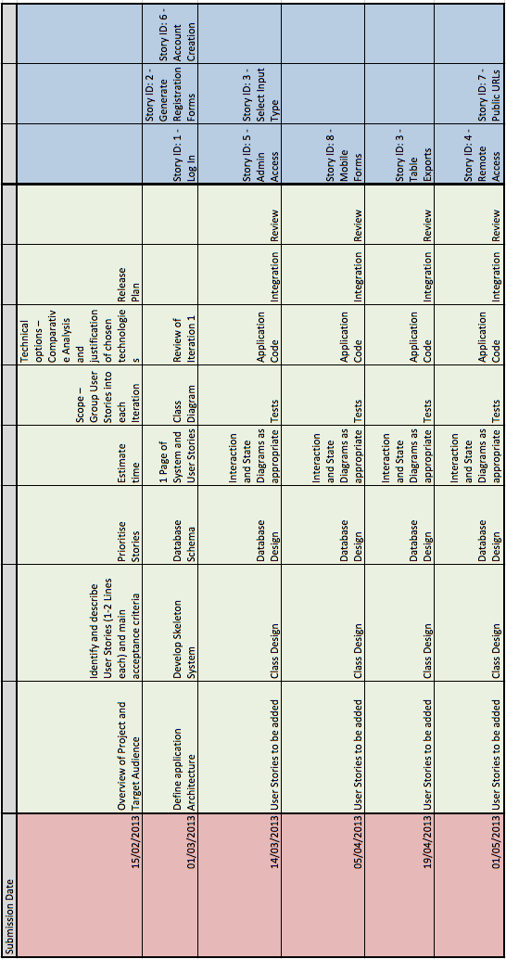

# Bibliography

W3SCHOOLS. HTML 5 Intro. Disponivel em: <http://www.w3schools.com/html/html5_intro.asp>. Acesso em: 05 December 2012.

ANDROID. Android. Disponivel em: <http://www.android.com/about/>. Acesso em: 07 December 2012.

ANDROID. Exploring the SDK. Disponivel em: <http://developer.android.com/sdk/exploring.html>. Acesso em: 07 December 2012.

IBM. Articles, online tutorials, and other technical resources on XML standards and technologies. **DeveloperWorks**. Disponivel em: <http://www.ibm.com/developerworks/xml >. Acesso em: 03 December 2012.

JQUERY. JQueryMobile. Disponivel em: <http://jquerymobile.com/ >. Acesso em: 30 November 2012.

MICROSOFT. ASP.NET Overview. Disponivel em: <http://msdn.microsoft.com/en-us/library/4w3ex9c2(v=vs.100).aspx>. Acesso em: 03 December 2012.

MICROSOFT. Getting Started with Azure. Disponivel em: <http://www.windowsazure.com/en-us/home/features/overview/>. Acesso em: 07 December 2012.

PYTHON.ORG. CSV File Reading and Writing. Disponivel em: <http://docs.python.org/2/library/csv.html>. Acesso em: 31 January 2013.

PARKER, R. How to migrate your ASP.NET site to the Azure cloud. **Developer Fusion**, 1 June 2011. Disponivel em: <http://www.developerfusion.com/article/119960/upgrade-your-aspnet-site-to-the-cloud/>. Acesso em: 03 December 2012.